**AUGUST DIY PROJECT REPORT**

***Team Name****-* ***The Wolf Pack***

***Team Members****- 1)Siddhesh Sali 2)Yash Bhavsar*

*3)Vinit Awale 4)Varun Ginde*

ARDUINO CONTROLLED VISITOR COUNTER USING ULTRASONIC SENSOR (ACVC)



**PROJECT DESCRIPTION:**

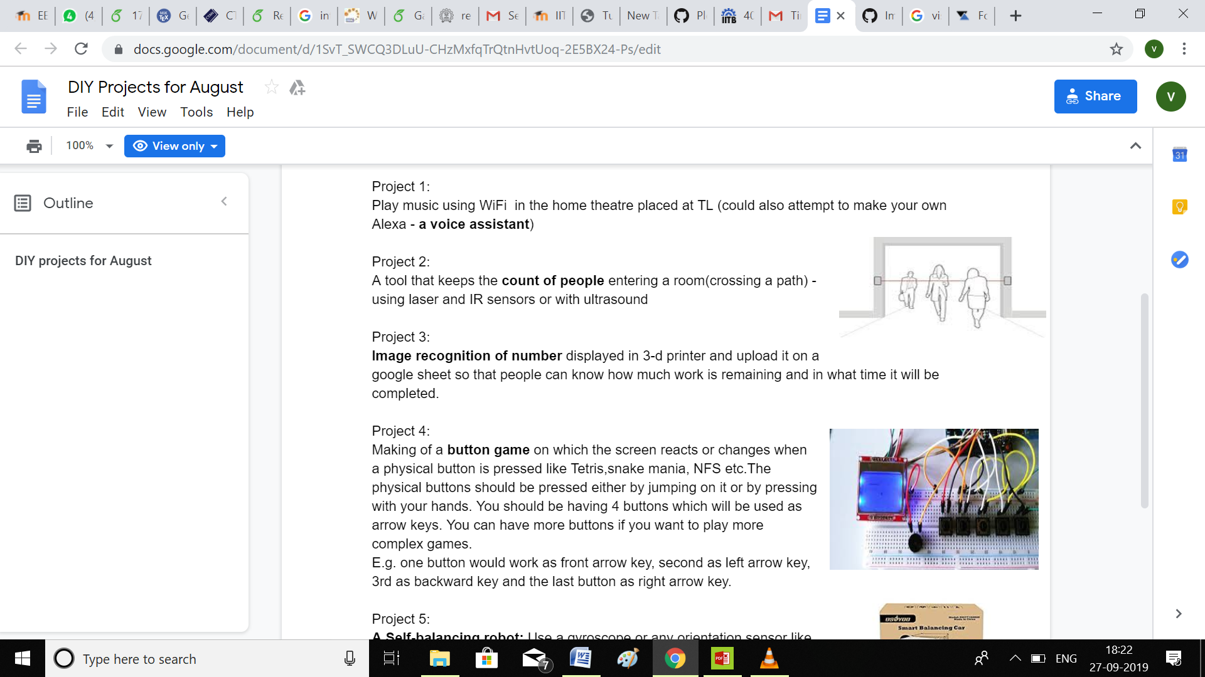

**ELECTRICAL COMPONENTS USED:**

* Ultrasonic sensor HC- SR04 (x2)
* Arduino Uno R3
* 16X2 LCD Display JHD 162A
* NodeMCU (Only used to upload the count on internet)
* DC Adapter for power supply

**CKT DIAGRAM:**

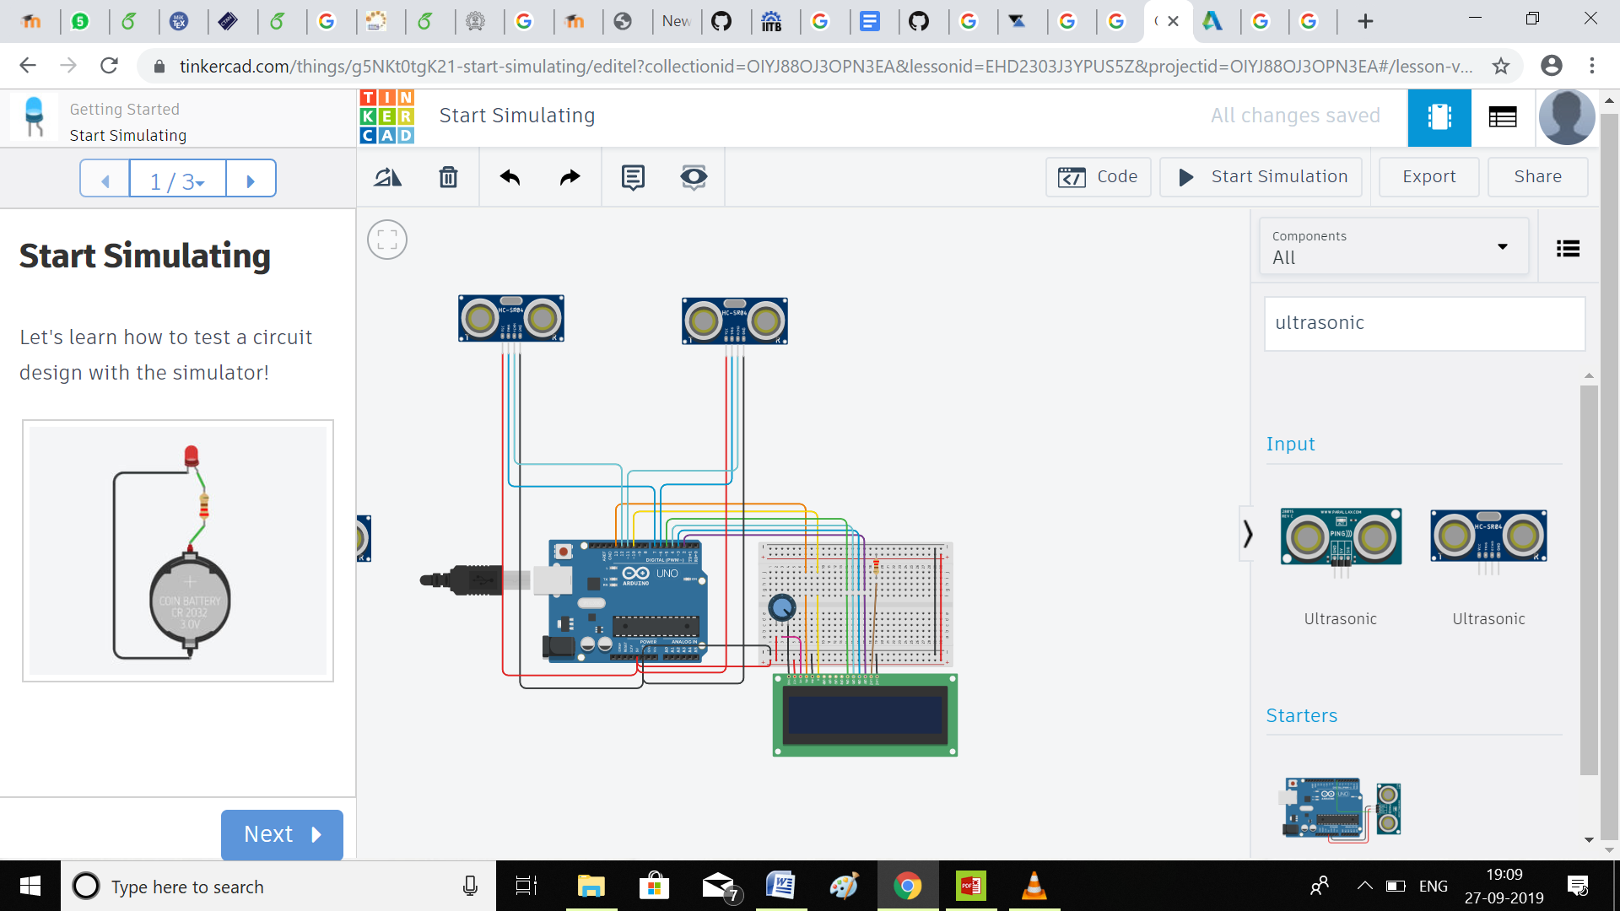

(Software used to make the circuit- Tinker Cad)

**ARDUINO CODE:**

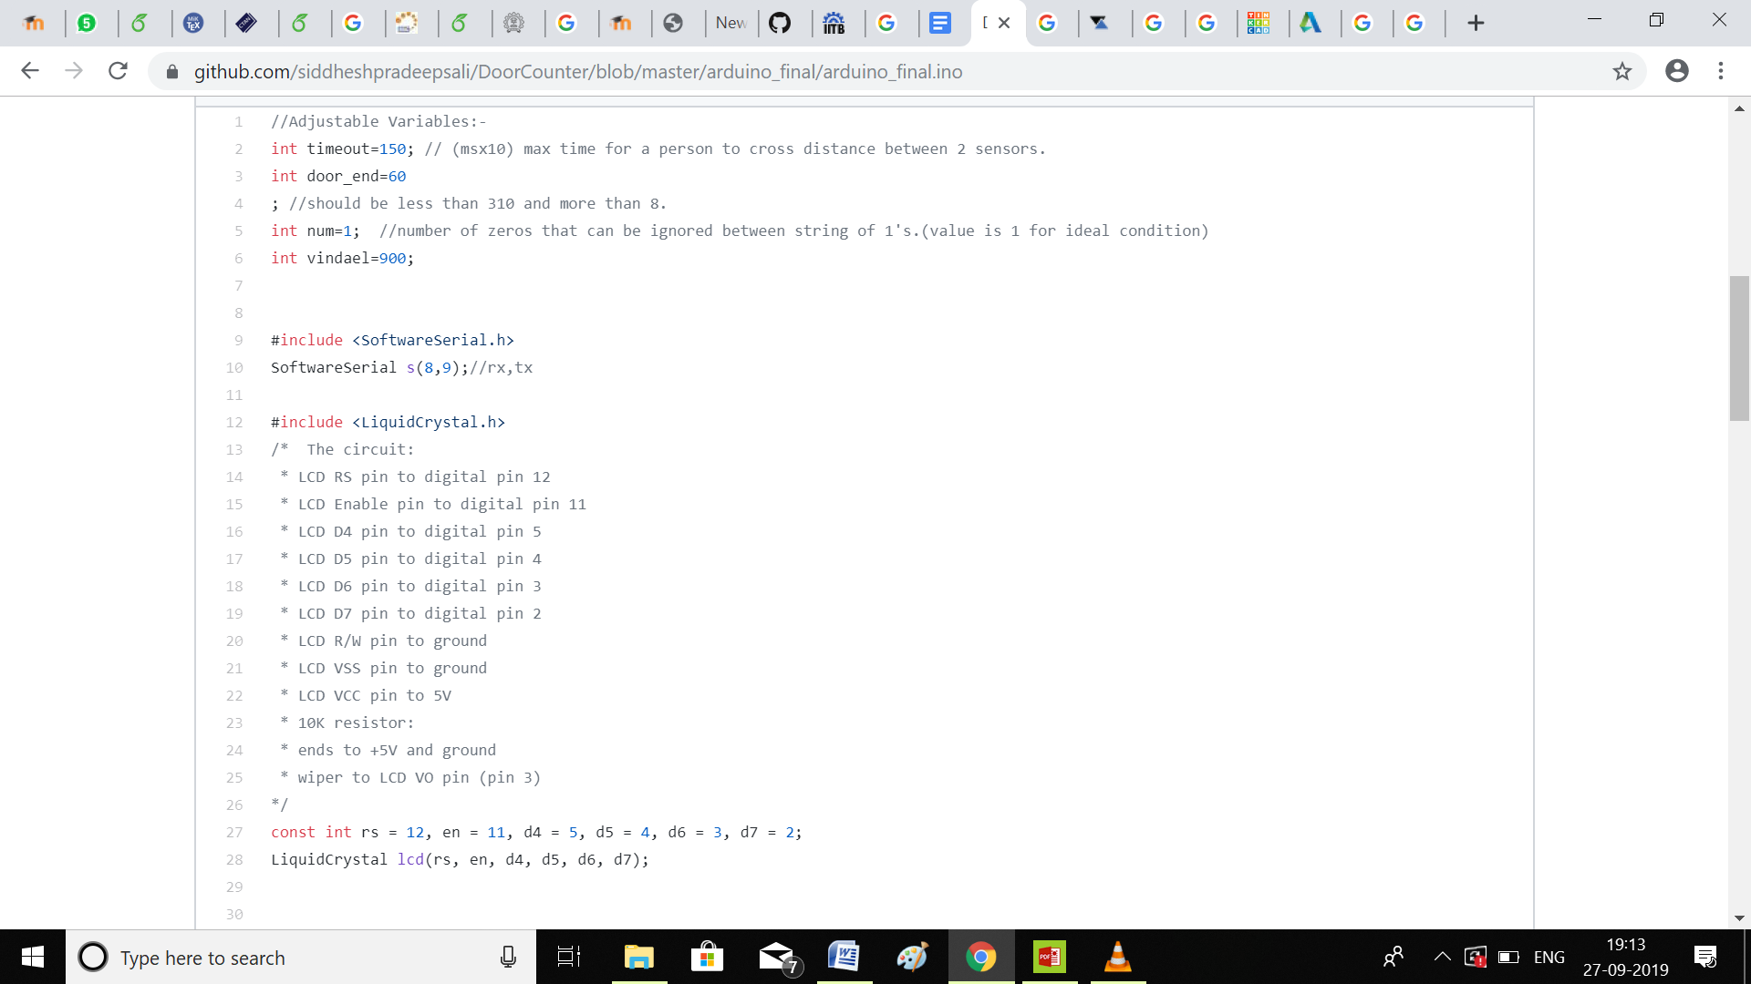 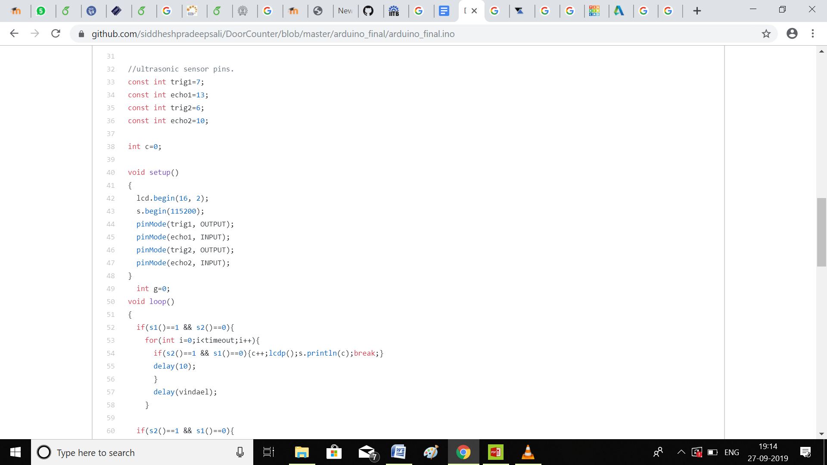

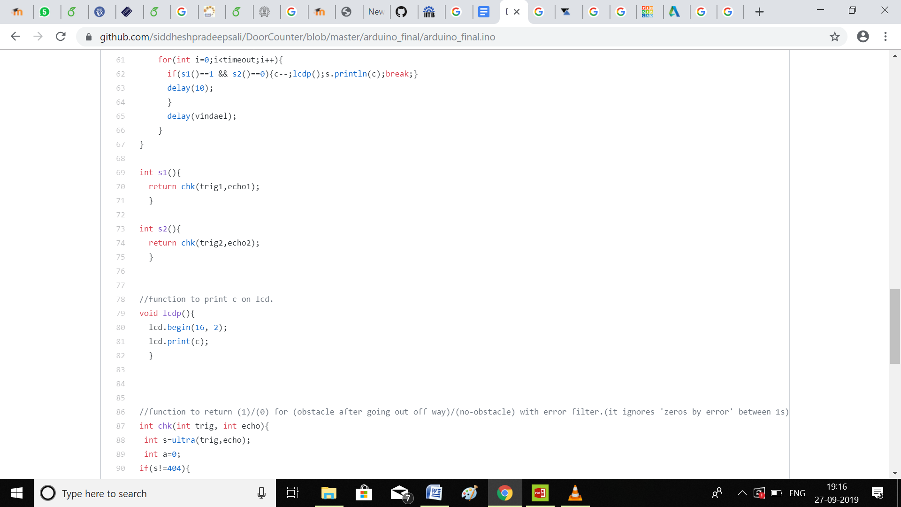

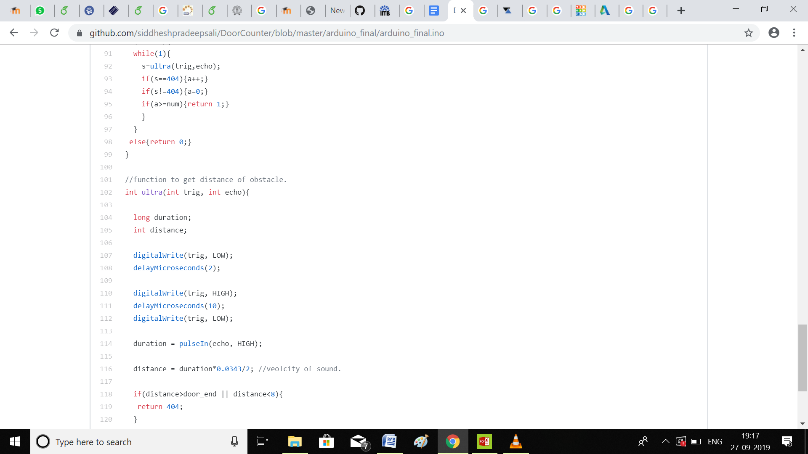

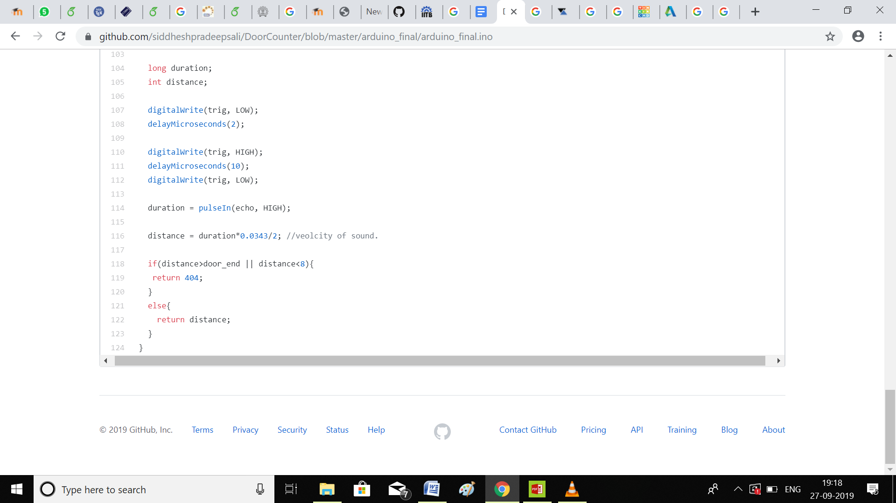

**CODE USED FOR MCU NODE:**

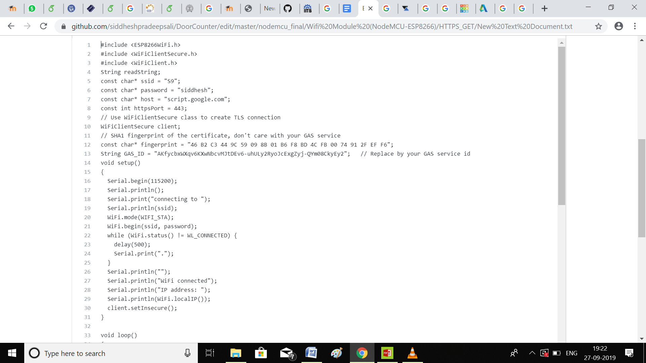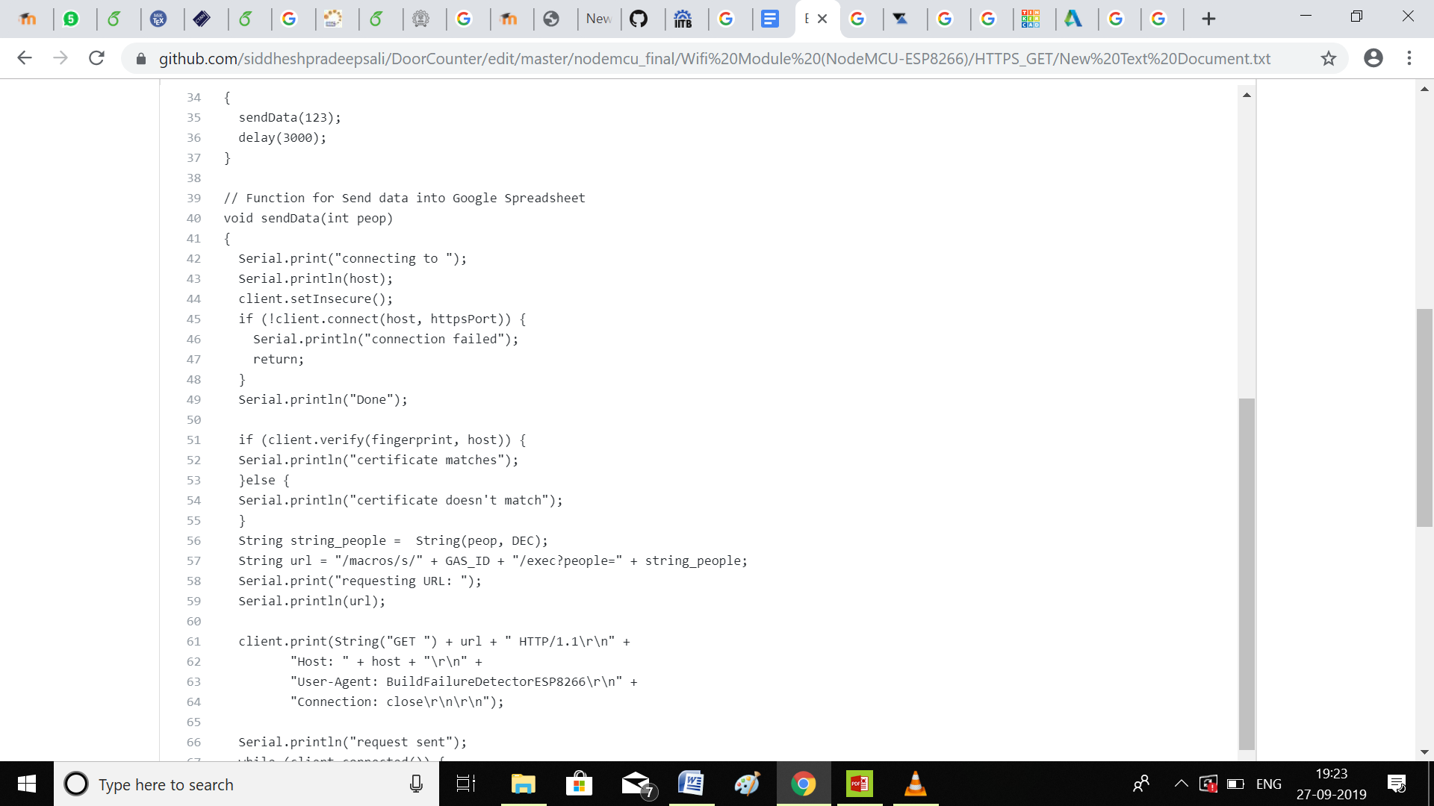

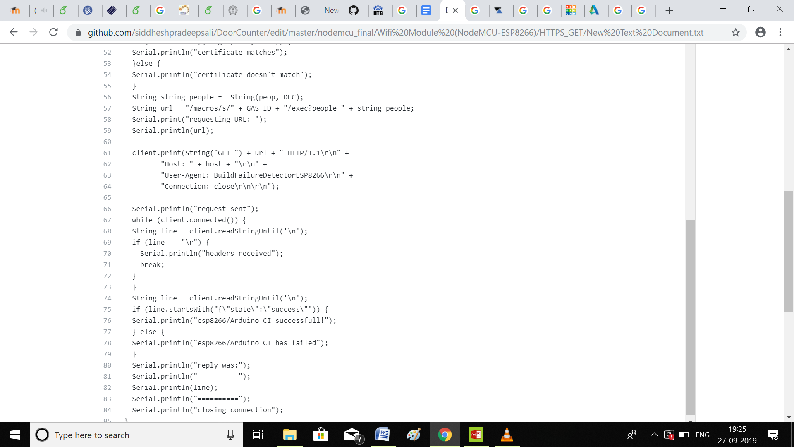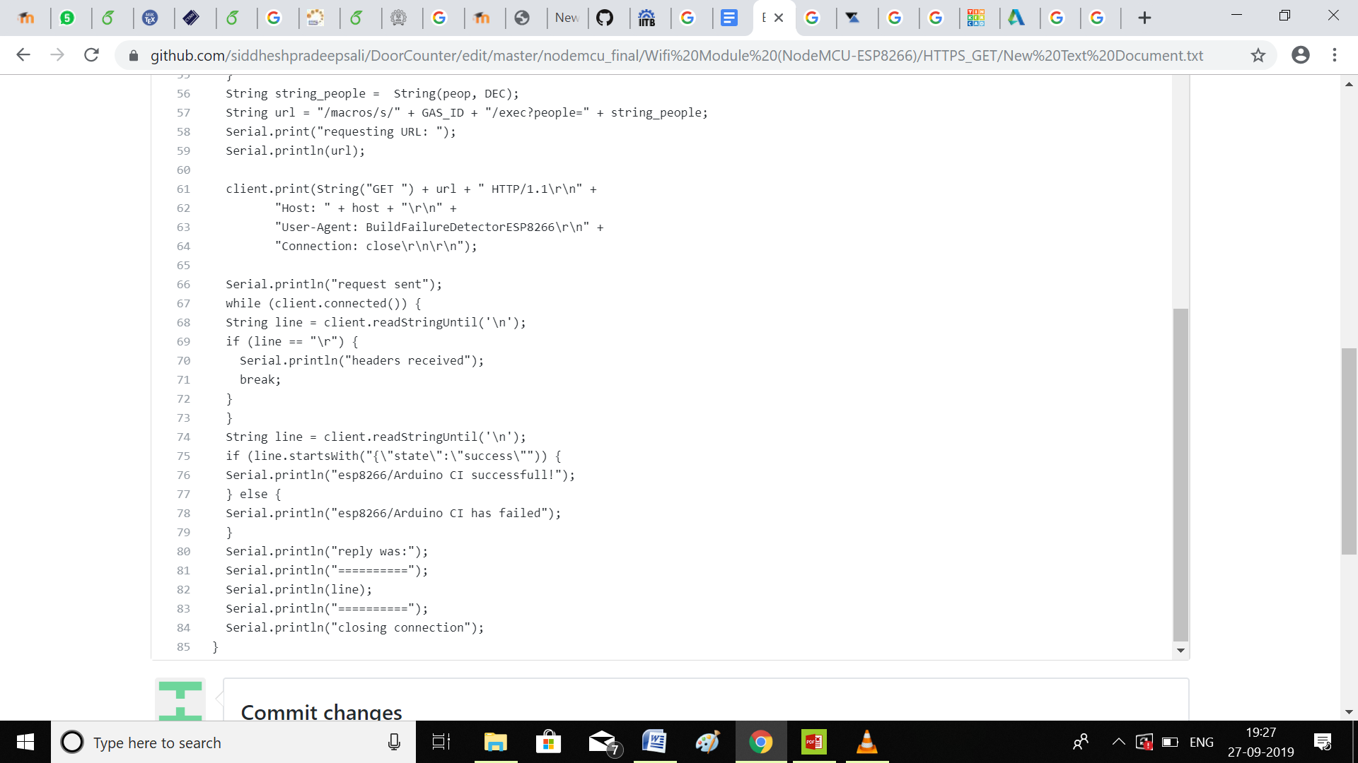

**ADDITIONAL FEATURES ADDED TO THE DESCRIPTION:**

* We have made the design to for a bi-directional visitor counter and hence it counts people entering as well as the people who are leaving the room.
* Along with the LCD Display we have added a Wi-Fi module using Node MCU which uploads the count on adafruit.io which can be used by a user who is far away from the door (or maybe even the room) to check the count of people without having to reach the door to have a look at the Display.

**IMPROVEMENTS THAT CAN BE MADE IN THE PROJECT:**

* The sensitivity of the project can be increased significantly if instead of ultrasonic sensors, long-range IR sensors are used (which are too expensive for this project) or a camera is used to implement object detection.
* Alarm can be added to the project to detect human activity at unusual hours.